CHAT PORTAL WITH FTP ENABLED (ECHOLINK):

Submitted By
Project Leader: Fatima Shakil
Roll Number: 22k-4016
Team Member: Zoha Zafar
Roll Number: 22k-4088


Department of Computer Science
National University of Computer & Emerging Sciences

Motivation:
The increasing need for secure, real-time communication and efficient file transfer solutions in educational and corporate environments inspired us to develop a unified chat portal with built-in FTP capabilities. ‘ECHOLINK’ not only supports seamless messaging but also ensures reliable file sharing and user management with an appealing and responsive interface.

Overview:
- Significance of the Project
The modern digital ecosystem demands tools that combine communication and collaboration. Most applications offer either group chatting or file sharing — not both with equal strength. EchoLink bridges the gap by providing both functionalities in a single platform.
  - Enables real-time collaboration between users with secure file sharing.
  - Offers academic value by applying real-world networking, backend integration, and front-end design principles.
- Description of the Project
EchoLink is a real-time web application developed using Flask, Socket.IO, and Python, allowing users to log in, chat instantly, and transfer files securely via FTP. The portal includes:
- login and registration
- WebSocket-powered messaging
- FTP-enabled upload/download functionality with access control
- UI/UX enhancements with a dark-themed interface
Users can access the platform from any browser and communicate instantly, while having the option to share important files which are stored in a secure backend system.

- Background of the Project:
We explored various technologies including Flask, Django, Spring Boot, and WebSocket libraries. Flask with Socket.IO was chosen for its simplicity and ease of integration with FTP modules.
References include:
      - Flask Official Documentation https://flask.palletsprojects.com/
      - Django Project https://www.djangoproject.com/
      - Spring Boot https://spring.io/
      - Comer, Douglas E. Internetworking with TCP/IP, Prentice Hall.
      - Stallings, William. Data and Computer Communications, Pearson.
      - https://www.bing.com/ck/a?!&amp;&amp;p=c6a39d586e21ce14cc0b557233ebd2e1f31ef0d42bcdafc76af220e4cbf90d78JmltdHM9MTc0MTIxOTIwMA&amp;ptn=3&amp;ver=2&amp;hsh=4&amp;fclid=14644c9a24d46d4b11c45fdb250f6caf&amp;psq=Flask+Official+Documentation&amp;u=a1aHR0cHM6Ly9mbGFzay5wYWxsZXRzcHJvamVjdHMuY29tLw&amp;ntb=1

- Project Category:
Product-Based Project
It is a complete working application created to help users chat and share files. It is not based on research or made for a specific company, but it can be used by anyone who needs a secure chat and file sharing system.

Features / Scope / Modules:
- User Authentication and Registration:
  - Users can securely sign up and log in to access the system.
  - Session management ensures authenticated communication.
- Real-time Chat Interface:
  - WebSocket-based chat allows multiple users to communicate live.
  - Messages are instantly updated in the interface without reload.
- FTP File Upload and Download:
  - Users can upload files to the server and download shared files.
  - Files are stored in the /uploads directory and access is logged.
- User Activity Logs:
  - Every message and file transfer are being logged for accountability and monitoring.
- Modern UI:
  - HTML, JavaScript and Internal CSS, provides a stylish and engaging user experience.
- Secure File Handling:
  - Only logged-in users can access files.
  - Upload/download routes are protected.

Project Planning:

Week | Task
Week 1 | Environment setup, FTP server configuration and Installation
Week 2 | Authentication system & real-time chat
Week 3 | FTP file transfer features & UI design
Week 4 | Full integration testing and documentation

Team Contribution
- Fatima Shakil: Backend logic, file handling, UI design and testing.
- Zoha Zafar: Real-time chat, Socket.IO, Flask routes, FTP integration

Project Feasibility:
Technical Feasibility
- All components are achievable with Flask, Socket.IO, and Python FTP libraries.
- Hosted on a local or cloud server with standard configurations.
Economic Feasibility
- No additional costs — tools and libraries used are open source.
- Requires a machine with Python and internet access.
Schedule Feasibility
- Four-week plan ensures timely completion with division of responsibilities.

Hardware and Software Requirements:
Hardware
- Standard PC or laptop with 4GB+ RAM
Software
- Python 3.x
- Flask
- Flask-SocketIO
- FTP server (pyftpdlib, FileZilla server)
- Browser (Chrome/Firefox)

Diagrammatic Representation of the Overall System
Figure 1: System Architecture of EchoLink

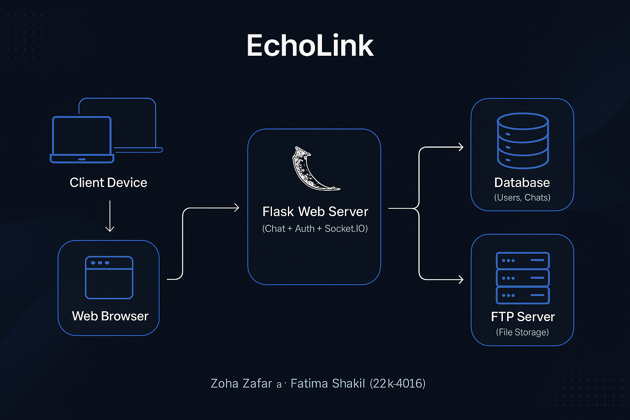

- Client Device Accessing to EchoLink via Web Broswer.
- Web Browser: Chat interface with UI
- Flask Web Server with WebSocket and FTP endpoints
- File System: Upload/download directory with access control
- Database: Chat and file activity logs for review

DEMO SCREENSHOTS:
LOGIN PAGE:
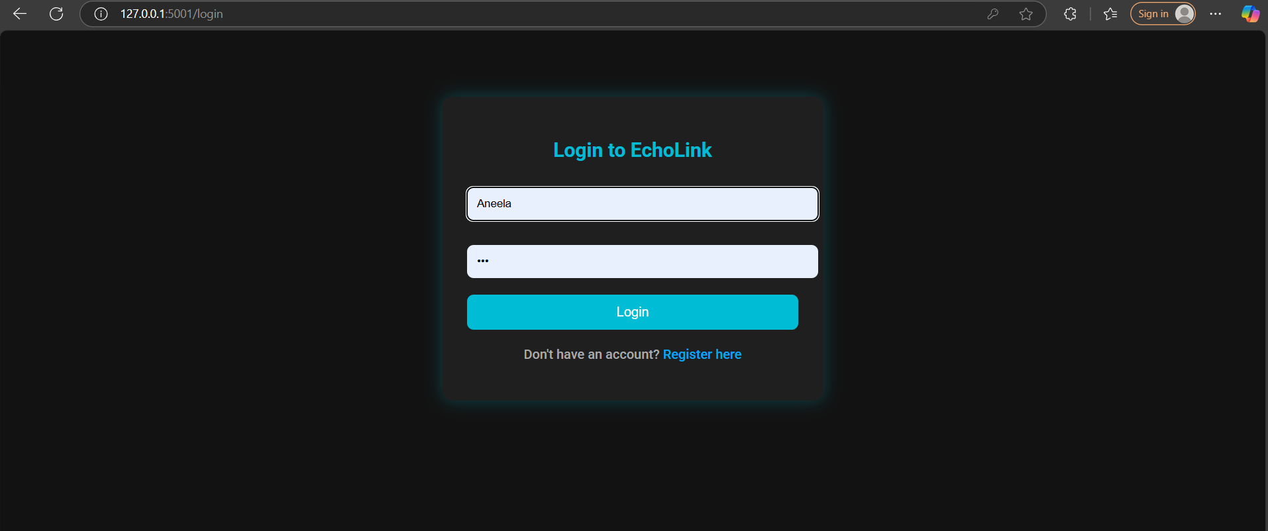

REGISTER PAGE:
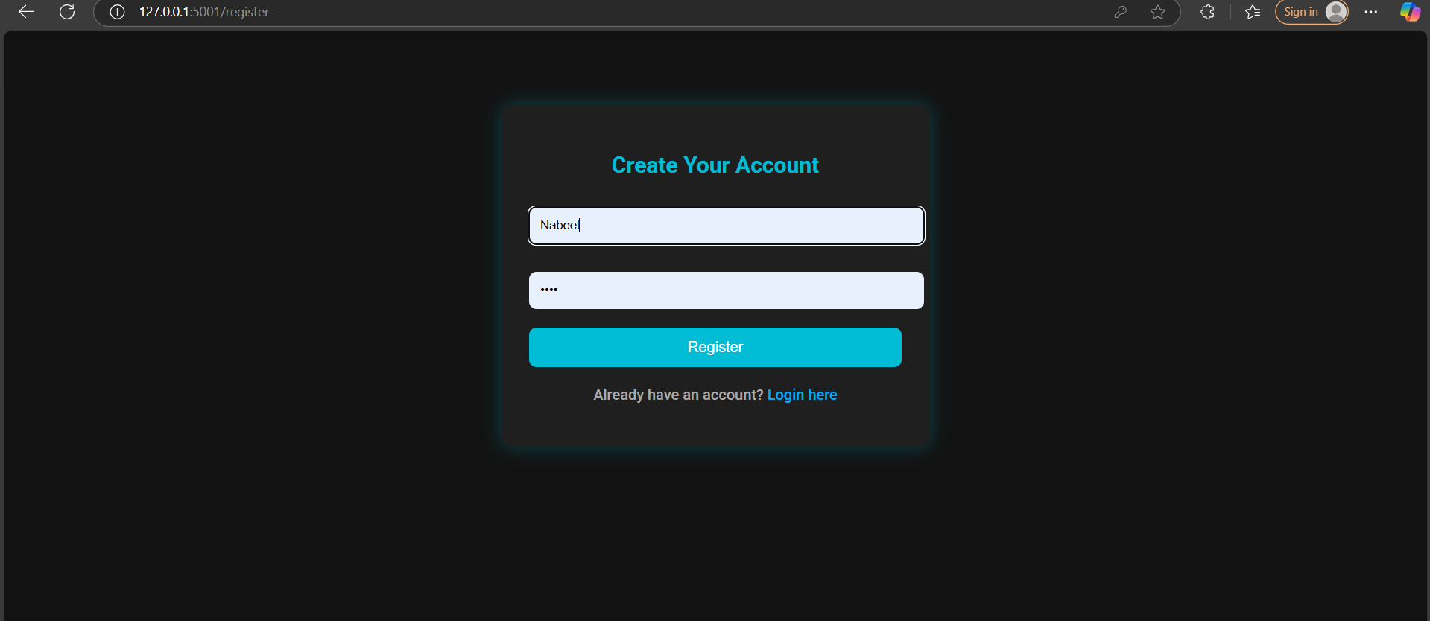

CHAT PORTAL
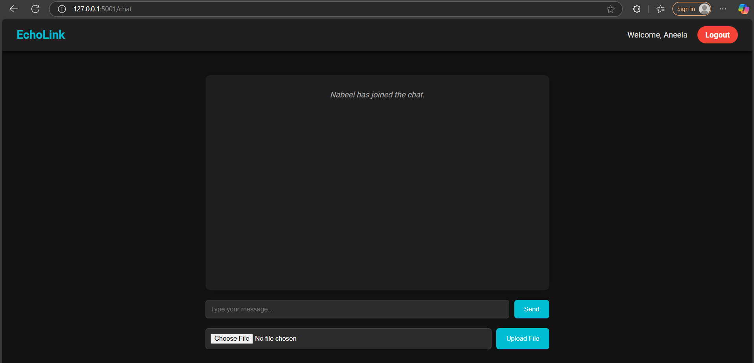

USER’S CHATTING:
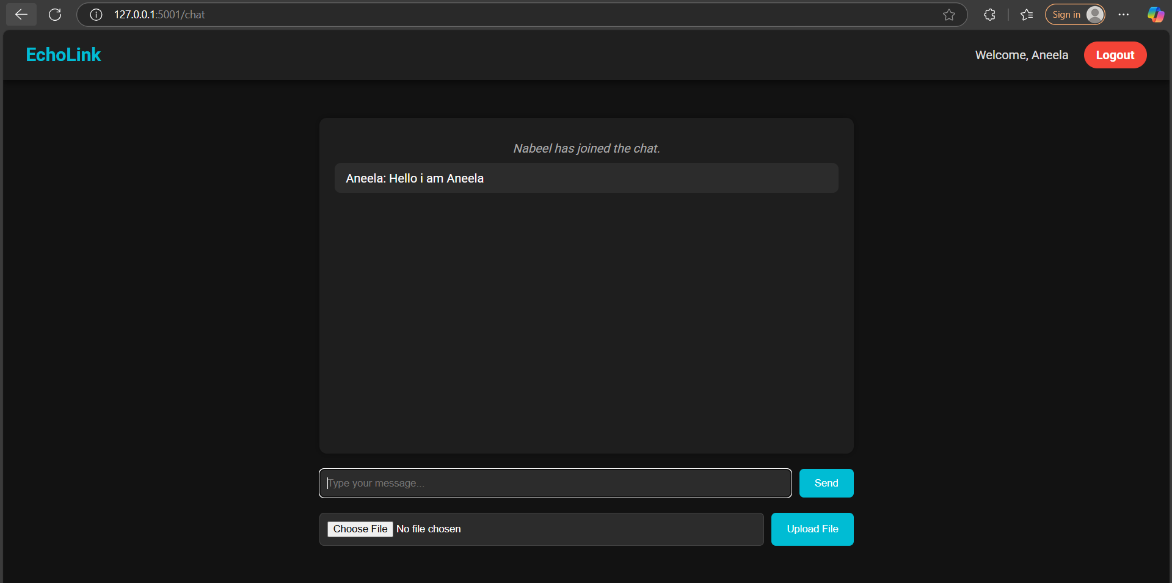
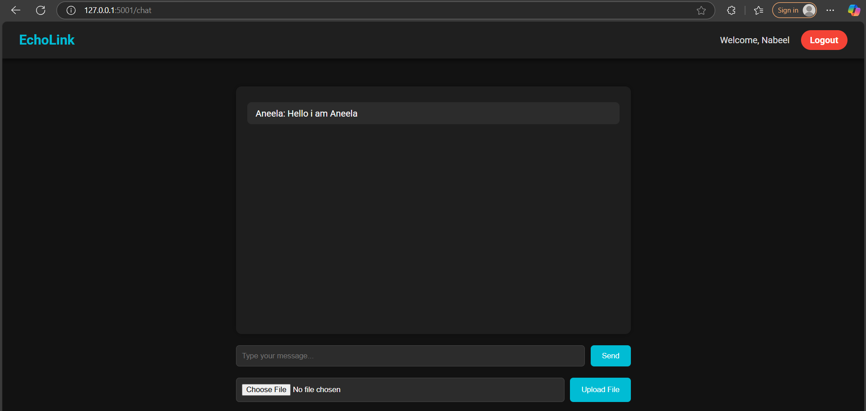

FILE TRANSFER:
1) Choose file:
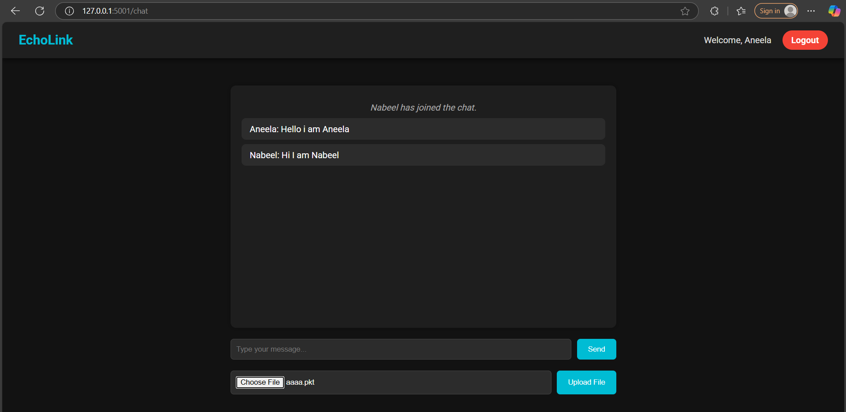

2) Upload file:
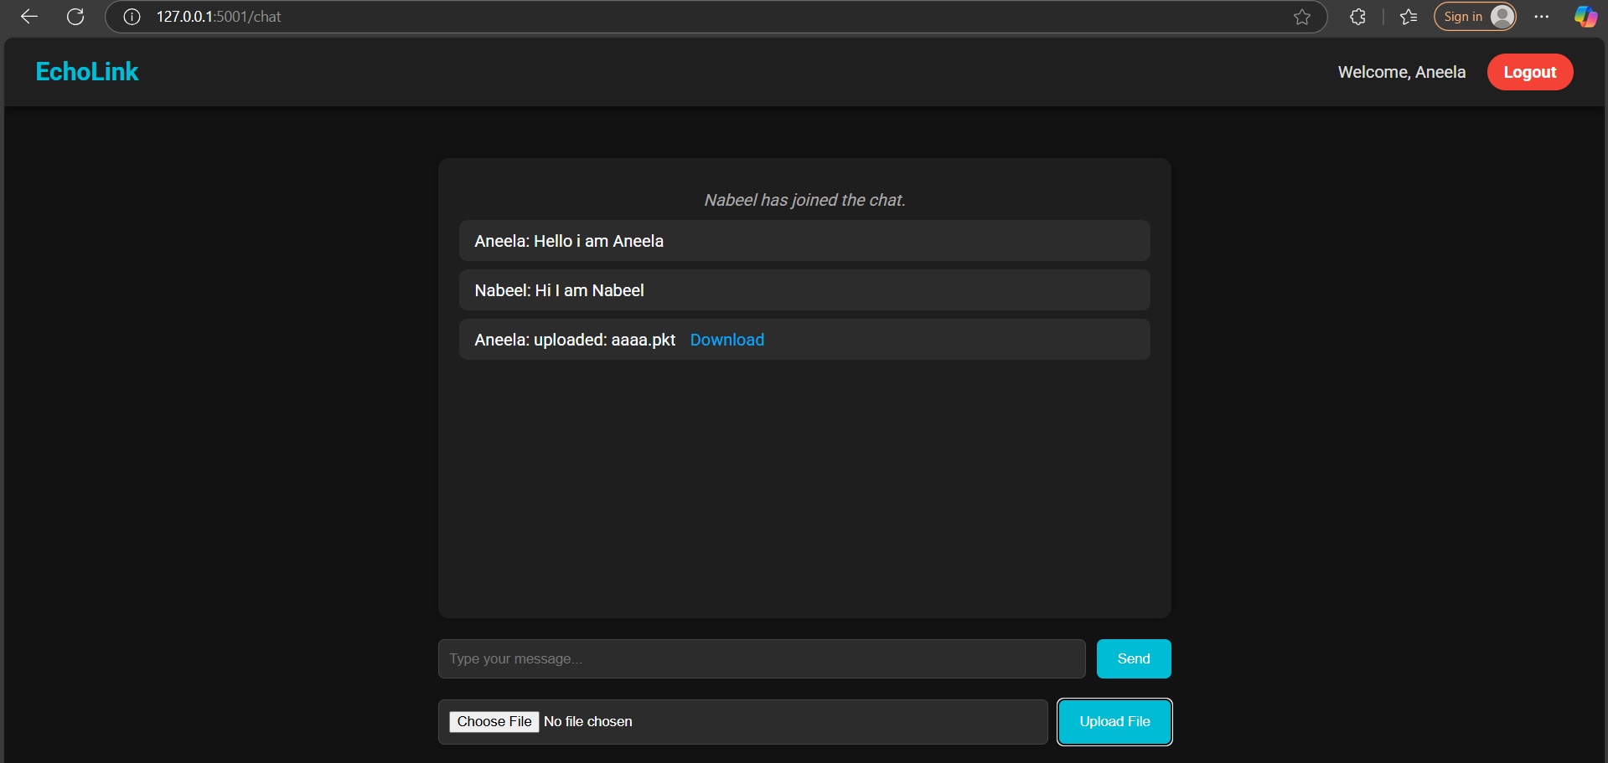

3) Download file:
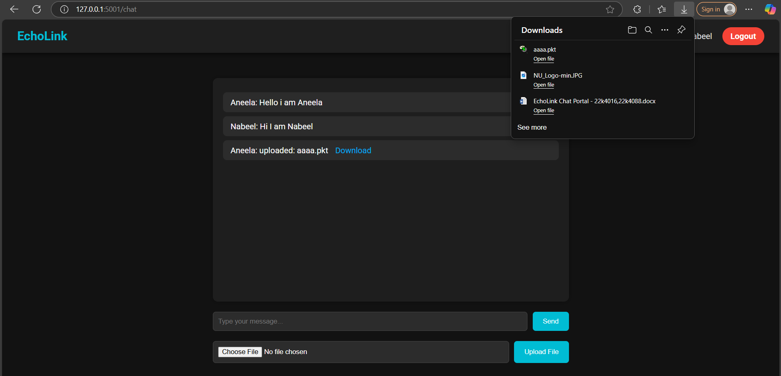

Notification to Other Users after Logout:
